**License # CF504585** **DHS: JM00014**

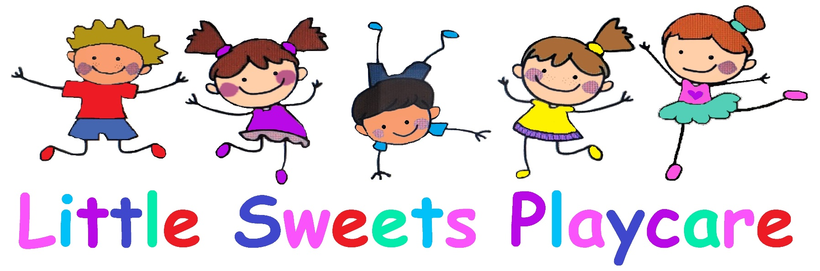

**Application**

**Preschool/Toddlers/Infant**

**Owner/Operator**

**Kara Enos**

**14758 N. Umpqua HWY**

**Roseburg, OR 97470**

**541-378-2584**

[**littlesweetsroseburg@outlook.com**](mailto:littlesweetsroseburg@outlook.com)

[**www.littlesweetsplaycare.com**](http://www.littlesweetsplaycare.com)

|  |  |  |  |  |  |  |
| --- | --- | --- | --- | --- | --- | --- |
| **#1. Child Information** | | | | | | |
| **Last Name** | | | **First Name** | | | **M.I.** |
| **Birthdate** | | **Nickname** | | |
| **Child’s Primary Physical Address** | | | | | | |
| **Street** | | | | | | |
| **City** | **State** | | | **Zip** | | |
| **Existing Medications (Please list all creams, sunscreen or medications)** | | | | | | |
|  | | | | | | |
| **Does your child have special needs? Yes / No If yes, please list below what they are and what you do for them?** | | | | | | |
|  | | | | | | |
| **Does your child have allergies? Yes / No If yes, please list below what they are and what you do for them?** | | | | | | |
|  | | | | | | |
| **Pediatrician Information: Name Phone** | | | | | | |

I give Little Sweets Playcare permission to call an ambulance or take my child to a medical facility in case of emergency.

Signature: _______________________________________________ Date: _________________________________

|  |  |  |  |  |  |  |
| --- | --- | --- | --- | --- | --- | --- |
| **#1. Child Information** | | | | | | |
| **Last Name** | | | **First Name** | | | **M.I.** |
| **Birthdate** | | **Nickname** | | |
| **Child’s Primary Physical Address** | | | | | | |
| **Street** | | | | | | |
| **City** | **State** | | | **Zip** | | |
| **Existing Medications (Please list all creams, sunscreen or medications)** | | | | | | |
|  | | | | | | |
| **Does your child have special needs? Yes / No If yes, please list below what they are and what you do for them?** | | | | | | |
|  | | | | | | |
| **Does your child have allergies? Yes / No If yes, please list below what they are and what you do for them?** | | | | | | |
|  | | | | | | |
| **Pediatrician Information: Name Phone** | | | | | | |

I give Little Sweets Playcare permission to call an ambulance or take my child to a medical facility in case of emergency.

Signature: _______________________________________________ Date: _________________________________

|  |  |  |  |  |  |  |  |  |  |  |
| --- | --- | --- | --- | --- | --- | --- | --- | --- | --- | --- |
| **Parent/Guardian Information (Primary Contact)** | | | | | | | | | | |
| **Last Name** | | | | **First Name** | | | | | | **M.I.** |
| **Relationship to Child** | | | | | | | | | | |
| **Home Address Street** (Physical Residents) | | | | | | | | | | |
| **Birth Date** | **Driver’s License** | | | | | | **SSN** | | | |
| **City** | | **State** | | | | | | | **Zip** | |
| **Cell Phone** | | | | | **Home Phone** | | | | | |
| **Email** | | | | | | | | | | |
| **Work Information** | | | | | | | | | | |
| **Employer** | | | | | | | | | | |
| **Address** | | | | | | | | **Phone** | | |
| **Parent/Guardian Information (Secondary Contact)** | | | | | | | | | | |
| **Last Name** | | | **First Name** | | | | | | | **M.I.** |
| **Relationship to Child** | | | | | | | | | | |
| **Home Address Street** (Physical Residents) | | | | | | | | | | |
| **Birth Date** | **Driver’s License** | | | | | | **SSN** | | | |
| **City** | | | | | | | | | | |
| **Cell Phone** | | | | | **Home Phone** | | | | | |
| **Email** | | | | | | | | | | |
| **Work Information** | | | | | | | | | | |
| **Employer** | | | | | | **Job Title** | | | | |
| **Address** | | | | | | | | **Phone** | | |

|  |  |  |  |  |
| --- | --- | --- | --- | --- |
|  | **Emergency Contacts and Authorized Pick Up** | | | |
| **1** | **Last Name** | **First Name** | | |
|  | **Cell Phone** | | **Work Phone** | |
|  | **Relationship to Child** | | | **Emergency Pick Up Only** |
| **2** | **Last Name** | **First Name** | | |
|  | **Cell Phone** | | **Work Phone** | |
|  | **Relationship to Child** | | | **Emergency Pick Up Only** |

Emergency Contacts will be called if Parents/Guardians could not be contacted.

Emergency Contacts Listed will also be considered Authorized Persons for Pickup in both

Non-Emergency and Emergency situations unless otherwise checked as “Emergency Pick Up Only”

It is important that your child feels safe with the people who you list above.

Any persons listed above that the provider has not met prior, will be asked for photo ID.

**Schedule**

Please indicate below estimated Drop Off and Pick Up times for each day your child will be attending daycare.

Also, no drop-off/pick-up between noon and 2:00 as this is nap time.

|  |  |  |  |  |  |
| --- | --- | --- | --- | --- | --- |
|  | Monday | Tuesday | Wednesday | Thursday | Friday |
| Drop Off Time |  |  |  |  |  |
| Pick Up Time |  |  |  |  |  |

Open Hours: 7:00AM–5:00PM (Early drop-off available)  
 Open Days: **Monday–Friday**  
**gInfant care: 1000.00** per month (0-1 years old)

**Toddler care: 950.00** per month (2 years old, or 2+ and not yet potty trained.)

**Preschool care: 900.00** per month 2+

**Arrive and Pick-Up when you are supposed to…**

We need to know when you plan on picking up and dropping off! This helps us plan our days, as early pick-up or late drop-off can interfere with our activities. Constant issues may result in extra fees and or termination.

With being licensed we, as a licensed daycare facility, are not only limited on the number of children in our care, but also limited on the ages of children in our care. With that said, our fees are based on SLOTS. You will be paying for your child’s slot in our playschool program, regardless if your child is in care or not. We will also no longer offer morning or afternoon care. We apologize for the inconvenience.

**Travel Permission**

Little Sweets Playcare goes on field trips 2x week! I give Little Sweets Playcare permission to drive my child/children to fieldtrips and to other activities, with prior notice. I will provide my child’s car seat, and understand Miss Kara or Little Sweets will not be held liable if an accident occurs.

**Sunscreen Release Form**

Sunscreen is considered a medication, and as such a medication release form must be filled out if you wish your child to have it applied while in care. Please see attached form.

**Trampoline, Swings, and Animal Permissions**

I give Little Sweets Permission to allow my child to jump on the trampoline during outside play and to play on swings, under adult supervision. Trampoline has safety enclosure.

* Check here if you do not want your child to play on the trampoline.
* Check here if you do not want your child to play on the swings.

I give permission to allow my child to interact with the Enos Ranch animals with adult supervision.

* Chickens Dogs Sheep

* Mini Horse Cats

**Pictures at Little Sweets Playcare**Why do I take your children’s pictures?  
I take pictures of your children throughout the day, primarily, to send to you, the parent. I take pictures of them playing, exploring and interacting with the other children. I also take pictures of the children holding up their art projects, as they are always so proud of their artwork and they love showing it off for a picture.

**Posting pictures on Facebook**

*Why do I need to post your child’s pictures on Facebook?*   
As a business owner, I must advertise to keep my positions filled, so that I can remain open and continue to care for your children. These pictures only go on the Little Sweets Preschool Facebook page. It allows people looking for childcare to see what we do here, how children are spending their day, and potentially giving them the insight to choose Little Sweets Playcare over other options.   
*I only post pictures on Facebook with your permission. However, your child may be in a picture in the background and, or where their faces are not visible.*

*Only check ONE box!*

Please check box if you would like pictures/videos of your child while at daycare ONLY sent via text.  
If yes, please provide the preferred Phone# to send picture texts__________________________________________

Please note: It is difficult to upload pictures to multiple people, so uploading them all to the facebook page takes a lot less time.

Please check box if it is okay to use pictures/videos of your child on the Little Sweets Facebook page.

**Child Information Sheet**

**Hi, My Name Is ________________________________**

|  |  |
| --- | --- |
| * My favorite color is______________________________ * My Favorite Movie is_____________________________ * My favorite Toy is_______________________________ * My Favorite Food is______________________________ * I like to play____________________________________ * When I’m sad I__________________________________ * When I’m angry I____________________________ * When I’m happy I____________________________ * I don’t like____________________________________ * I really like___________________________________ | * When I’m hungry I_____________________________ * When I’m sleepy I______________________________ * I’m scared of__________________________________ * I don’t like_______________________________ * I really like_______________________________ * When I’m hungry I_________________________ * When I’m sleepy I__________________________ * I’m scared of________________________________ * And_______________________ makes me feel better. |

**Potty Training**   
(Only fill out if applicable to your child)

If your child is 2+ and potty training, they must be in pull ups, *not diapers*.

Please detail your potty training practices at home and what degree of commitment the parents are at, during this stage.

It is important that all the answers below are 100% honest—no answers will affect child’s acceptance to Little Sweets Playcare, but they will affect how well this process goes for both the daycare and the parents at home. A successful journey to potty training is in everyone’s best interests.

How long have you been Potty Training?   
Has your child gone potty in the toilet successfully?

How frequently do you have your child sit on the toilet?

Does child get upset at a dirty Pull-Up?

Does your child tell you when they go in Pull-Up?

What incentives/Rewards do you give?

Do you need help/ideas for Potty Training?

How committed are you to potty training your child? (1-not committed, 10-extremely committed.)

1 - 2 - 3 - 4 - 5 - 6 - 7 - 8 - 9 – 10  
Please List any additional information that can be helpful

|  |  |  |  |  |  |  |  |  |  |  |
| --- | --- | --- | --- | --- | --- | --- | --- | --- | --- | --- |
|  |  |  |  |  |  |  |  |  |  |  |

**Payment Details**

Child’s Immunization Records must be provided before child can start, even if the form is blank.

* Full Time (4-5 Days per week)
* Part Time (3 or fewer days per week)

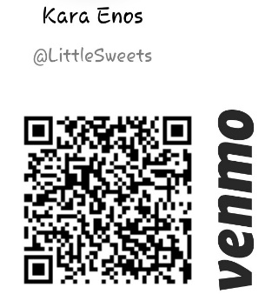Preferred Payment Method

* Cash
* Venmo
* PayPal (send $ to a friend. KMEnos@live.com)
* Check
* Square (debit or credit)

Invoice/Receipt Preferences

* Text (PREFERED PH#)( ) -
* Paper form (will be given in person)______________________________________

My Child(ren) is/are Potty Trained

* Yes
* No – Child’s Name__________________

Signing this page means you have read *and* agree to the entire Registration Packet for Little Sweets Playcare, and that the information given is true to the best of your knowledge.

Name of Parent/Guardian: ________________________Date:_________   
 Signature of Parent/Guardian: ______________________________

**Requirements/Information for you to keep for your records**

* + - First payment is due *before* child’s first day. (Unless otherwise discussed.)
* Payments are due on the 1st of the month. *(Ex: You pay for all scheduled days in June, on June 1st.)*

OR on the following Monday IF the 1st falls on a weekend. (Unless otherwise discussed.)

* Late Payment Fee: **$10.00 PER DAY! (4 day grace period)** Late Charges continue for up to 30 days! That’s 300.00!!!
* DHS Payments— Co-pays and or overages are due the first Monday of each month!
* Childcare will be suspended after 5 days of non-payment. Childcare will not resume until payment + late fees are paid in full.
* In the event your account is not paid in full within thirty (30) days of the due date and you have not reached an agreement with Little Sweets Playcare on a payment plan to pay the balance due, your account may be turned over to a collection agency and you will be responsible for paying all collection agency fees and/or all attorney fees for collection of monies due.
* All personal belongings left behind after childcare has been terminated, becomes property of Little Sweets Preschool, if left unclaimed for 30 days.
* If your child is sick, or SHOWING ANY SYMPTOMS you *must* keep them home—this includes, but is not limited to: Fever, vomiting, yellow/green snot, diarrhea, and impetigo. They cannot return until they are symptom free for 24 hours. If your child becomes sick during care, child *must* be picked up immediately. If you drop off a sick kiddo and get the teachers or other kids sick, we will be forced to close until the sickness has passed.
* Changes to schedule need to be requested at least two weeks in advance and will be approved based on availability.
* Any Early Drop Off and Late Pick Up fees accrued will be due with next following payment period.
* **Part Timers**–Possibility to be moved off the schedule to accommodate new clients needing more hours. The child with the fewest hours will be the first to be bumped, with a two-week notice.
* Parents/Guardian’s must sign child in at drop off and again at pickup.
* Parents are responsible for packing children a nutritious lunch each day. (A $3.00 flat fee will be accrued if a child is sent without a lunch or the lunch is not adequate.)
* **Little Sweets Playcare recognizes all major holidays/school closures and as such will be closed.**
* A two-week notice is required prior to leaving childcare at Little Sweets Playcare, or dues for those weeks will be required.
* Little Sweets also takes **Christmas Eve through the New Year off, as well as Spring Break and a full week during the Summer.** These months will be prorated for the weeks off.
* Little Sweets Playcare does have an, on-call, substitute, but there may be times they are NOT available. Parents are responsible for having backup care arrangements in case this happens last minute.
* Completed Registration Form *MUST* be returned before child’s start date along with the 75.00 enrollment fee. Every year following it will be 35.00 to re-enroll.
* Immunization Records are required, even if the child does not receive them.

**Attendance Information**

* **Early Drop Off** —Arriving 6 or more minutes earlier than **scheduled**, will result in an additional $5.00 fee.
* **Late Drop Off**—No fee. No money will be refunded for time missed this way. (But if dropped off late, we cannot guarantee we will be open, as we may have left for a fieldtrip!)
* **Early Pick Up**—No Fee. No money will be refunded for time missed this way. But we may still be gone on a field trip! So you are REQUIRED to call first!
* **Late Pick Up**—Arriving 6 or more minutes later than scheduled, will result in an initial $5.00 fee, and an additional $5.00 every 5 minutes late.
* **Excused Absences**—Scheduled Vacations. Days missed this way, already paid for, can be rolled over toward the following month. *(At the discretion of the provider.)*
* **Vacation** - A two weeks’ notice is required for it to be considered an Excused Absence.
* **Unexcused Absences**—Any days missed, not related to requested vacations.

No days will be refunded/rolled over, for unexcused absences. Unfortunately, we cannot roll over sick days.

* **Vacations** – Failure to notify provider in required time frame, will be marked as an unexcused absence, resulting in charges for days your child was originally scheduled, *regardless of their attendance*.
* **Sick Time** – Notify provider as soon as you are aware the child will not be attending. If you attempt to drop your child off knowing that they are sick, the child will be sent back home with you or you will be called for immediate pick up. Multiple instances will result in termination. It is unfair to the staff and other kids in care to bring in bugs and get them sick.
* **Last minute days off** – If you have a last-minute day off please notify provider asap, even though it is considered unexcused.

___________________________________________________________________________________________

**Two-Week Trial Period**

The first two weeks of attendance (8-10 actual days of care) is a trial period for both the parents and the provider. During the two-week trial, the parent or the provider can terminate the childcare contract without reason or notice at any time. There will be no reimbursements for any part of the first two weeks of care in the event of termination.

The provider reserves the right to extend this trial period and give immediate termination where there are extreme circumstances that affect the well-being of the provider or other children in attendance.

**Reasons for termination can include, but are not limited to:**

|  |  |
| --- | --- |
| * Violation of contract or policy and procedures by the parent * Refusal to stay in contact with Provider * Failure to complete the required forms * Failure to pay fees in accordance with the contract * Continuous Rest Time Disruptions * NSF checks | * Child Behavior/Inability to meet the child's needs * Lack of Parental Cooperation * Physical or verbal abuse of any person or property * Habitual Late Pick Ups/Early Drop-offs * Intentional dishonesty on Daily Health Questionnaire |

Part Time children may be moved off schedule to accommodate a Full-Time child.

**Parent Terminating care**

A two-week notice is REQUIRED! Failure to give notice will result in charges due for the two-week period regardless of attendance! All personal belongings must be picked up within 30 days of the child’s last day, any items left behind will become property of Little Sweets. Forms can be provided upon request.

__________________________________________________________________________________________________

**Rest Time at Little Sweets Playcare**

Naptime is important at Little Sweets for all our kids. It helps them continue to have fun and enjoy learning through the latter half of our day.

I encourage naps for ages 0-5. Everyone in this are range naps or must lay down and rest their bodies.

Children who do not nap, *must* remain quiet and respectful to those who *are* napping.  
It is important that your child can nap or rest during nap time without disrupting other children.

**Why Napping Matters**

As kids grow and develop, naps give their bodies and minds time to rest and recharge during those big changes. Plus, if children get overtired, it’s actually harder for them to fall asleep easily at nighttime. There are other benefits, too:

**Naps help kids learn.** One study of preschool children found that napping helped them do better at playing a memory game. The ones who got the greatest benefits from the nap were those who made a habit of snoozing every day.

**Naps help kids stay fit.** Research shows that kids who don’t get enough sleep – or who get irregular sleep – tend to have higher rates of obesity. Part of the reason may be tied to how they eat when they’re tired. Some studies have found that kids tend to eat more when they don’t sleep enough. They also tend to choose foods that aren’t very healthy. Plus, when kids are tired, they won’t have as much energy to be active and get enough exercise, another key part of having a healthy weight.

**More sleep, better mood.** It’s not news to parents that napless days can be full of tantrums and tears. And science backs that up: One study found that 2-year-olds who skipped their naps were less joyful, more anxious, and had a worse reaction to frustrating events.

**Additional Details**

**Food/Drinks**

Breakfast, like cereal, and snacks are provided in morning and afternoon. Parents are responsible for providing an adequate, nutritious lunch for their child, including a protein *(Meat, cheese, yogurt.)* Failure to do so will result in an additional charge due the 1st of the following month. If your child needs specific snacks *(allergies, picky eater, etc.)* please provide those for during snack times. Also, due to your providers own allergies, we ask that you do NOT pack your child muffins or crackers if your child cannot eat them without making a mess, as they are very crumbly and can make Miss Kara sick!

Please bring a *spill resistant* cup or cup with a closable straw, with child to drink water throughout the day.

**Playtime/Learning**

Morning Circle time, and Preschool work involve: music, youtube educational and workout videos, flashcards, and more. Educational games and toys are provided. We also help feed farm animals and gather eggs. Outside play is encouraged at least twice daily if weather permits. Disney movies and other age appropriate content will be played on occasion in the playroom.

**Discipline**

No physical discipline *(Spanking).* Redirection and Time Outs are used as necessary.  
Time Outs - 1 Minute per year old, sitting in time out chair.

**SNACKS AND LUNCHES – We do NOT provide lunch.**

It is the parents’ responsibility to pack an adequate lunch for their child. We do have a microwave.

Also please note that Miss Kara does have Celiac Disease, so we ask that when packing lunch, you take crumbs and messes into consideration and try and pack a lunch that is not too messy as it is possible it could make her sick.

Breakfast – 7:00 – 7:30AM

Morning Snack – 9:00AM

Lunch – 11:00 – 11:30PM

Afternoon Snack –3:00PM

*If a child is still hungry before pickup and there are any items left over from their lunch, they will be given the opportunity to eat that after Afternoon Snack.*

Water is available to your child the entire time they are here—we do not provide juices or milk.

**Below is a list of the *most common* foods given at snack times.**

Apple Slices

Oatmeal

Peaches

Veggie Straws

Cereal

Apple Sauce

Goldfish

Fruit Snacks

Cheerios

Orange pieces

Banana Slices

Carrots

**Below are lunch recommendations** *(These are in case a parent isn’t sure what to pack!)  
(You MUST include a protein and fruit/veg in your child’s lunch!)*

Lunchables (They make half size Lunchables now)  
Microwavable Soups

Fruits *(Sliced and peeled, please)*  
Hot Pockets

Cheese

Lunch Meats

Fruit cups

Sandwich

PP&J

Yogurt

**First Day Check List!**

We ask that these items be left at the daycare, and that large diaper bags be left at home.

|  |  |
| --- | --- |
| * Change of Clothing **(Bring in ziplock bag with child’s name on it)** * Diapers/Wipes *(If child is not potty trained)* * Small Blanket **(Please write name on tag)** | * Sippy Cup **(With Name written on it)** * Comfort Item *(Lovey, blanky, teddy, etc.)* |

Please bring your child’s lunch and jacket on a daily basis. We will send home a reminder if diapers or wipes are getting low, and or if your child needs a new set of extra clothes. Blankets/Jackets will be washed once a week or as needed/sippy cup washed as needed and again at the end of each day used. Any items you choose to leave here must be labeled with Childs Name or Initials.

**Toys from Home**

Sometimes children need to bring a special toy or newfound treasure to use as a “bridge” between home and childcare. On these occasions we will work with you and your child to try and make it a positive experience. However, past experience has shown us that toys from home often create problems at the daycare. We encourage you to keep these items at home. If an item becomes a problem, we will not allow it back.

**Holidays**

**Little Sweets Playcare recognizes all Holidays and will be closed.**  
While we are aware not everyone has these holidays off; they are important times for *our* family to spend quality time together.   
We would like to allow for families to prepare for other accommodations for these days if they are needed. We apologize for any inconvenience this may cause.

Martin Luther King Jr. Day

Juneteenth

* Thanksgiving Day (And the Friday after)
* **Christmas Eve – New Years Day**

**(Starting back up on Jan 2nd)**

* **One Full Week in the Summer**

**(To be determined)**

* New Year’s Day
* Memorial Day
* Independence Day
* Labor Day
* COVID Quarantine
* Weather Hazards

In case of non-holiday, days off, like weather issues, we try to keep families as updated as possible. As always, it is the parents responsibility to have back up care in case we have to close unexpectedly due to weather, illness, or something else.

**Provider Sick Day Policy**

Unfortunately, sometimes I will become sick. Working with children, this happens even more frequently. I will notify parents when I (or my child) become sick and either let you know that you can bring your child, but they will be exposed to my illness *(Mild Cold symptoms)* **or** that you will need to use your back up care. *(Severe Cold/Flu symptoms)*

**Child Sickness Recap**

Please remember to keep your child home if they are showing signs of illness!

**Runny nose:** *green, or clear if we have to wipe or blow your child’s nose more than once an hour they are sick.*

**Temperature of 99.0+** is considered a brewing bug, and child needs to stay home or will be sent home.

**Coughing/Sneezing:** If your child coughs or sneezes repeatedly, they are considered sick and child needs to stay home or will be sent home.

**Gassy eyes/Splotchy Face:** Your child is sick and needs to stay home or will be sent home.

It is unfair to the other children in care and to our staff for you to drop your child off sick. It’s better to get time off work to keep your child home than force our daycare to close for a full week, because you passed a bug to everyone.

Parents are responsible for making sure they have backup care in cases like these.

**Emergency Plans**

In case of an emergency:

Child care provider must have the following:

Child Information and Emergency binder

First Aid Kit

All children in care

**If we are in the activity center and need to evacuate, we will go to the water spigot in the parking lot.**

Teacher will grab the Children’s Information book and a First Aid kit, emergency bag, and all the kids and walk out the front door and across the driveway to stand at the spigot in the parking lot. The teacher will then take attendance, access safety/medical concerns, and call parents.

**If we cannot re-enter either the activity center we will go to the house and make contact with all parents to let them know.**

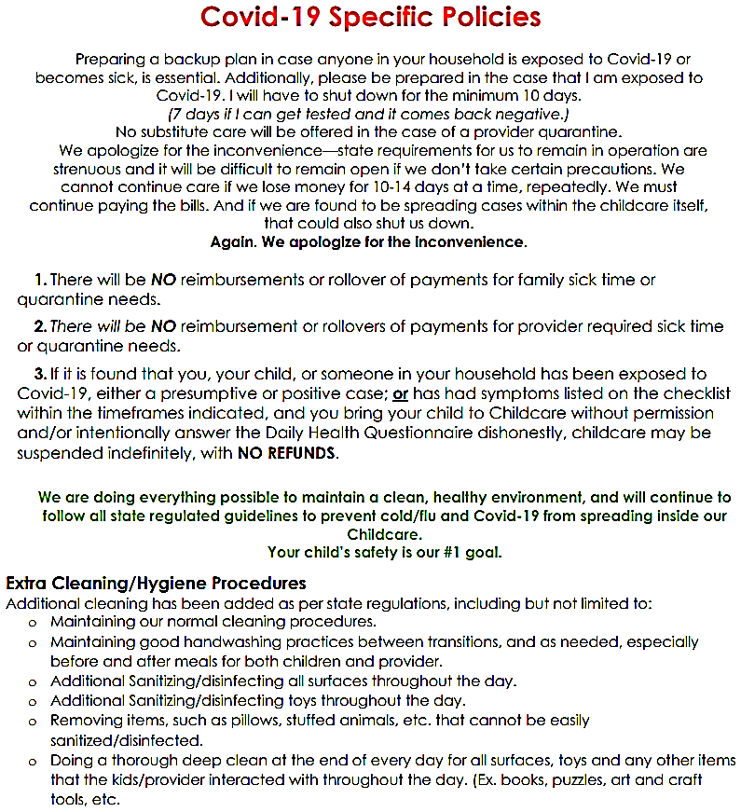

**Daily Schedule**

Please keep in mind we have field trips every Tuesday and Thursday!

We leave at 8am and come back between noon and 3pm!

**6:30 – 7:30 Quiet Time**

(Movies/TV, NO SCOOTERS. **GREET KIDS/PARENTS**)

**7:30 - 8:30 Play Time**

**(CHANGE ALL DIAPERS/TAKE KIDS POTTY)**

**8:30 - 8:45 Clean up/Preschool Time**

(Art project : Painting or Craft, name tracing)

**8:45 – 9:00 Circle Time**

(ABC/Counting Song, Tooty Ta)

**9:00 – 9:15 Snack Time**

(WASH HANDS: Milk, paper towels, cereal, veggie)

**9:15 – 11:00 Outside Play**

**(CHANGE ALL DIAPERS/TAKE KIDS POTTY before letting them outside.** Clean tables**)**

**11:00 – 11:30 Lunch**

(Milk, protein, grain, 2x veg/fruit. Clean tables after)

**12:00 – 2:00 Nap Time**

**(CHANGE ALL DIAPERS/TAKE KIDS POTTY before laying them down and AGAIN after they wake up! Clean up/Sweep/Mop)**

**2:00 – 3:00 Quiet Time**

(Movies/TV, NO SCOOTERS)

**3:00 – 3:15 Snack Time**

(WASH HANDS: Milk, paper towels, cereal, veggie)

**3:15 – 5:30 Outside Play**

(**Clean Tables. Make Sure room is picked up.** **Thoroughly** **check/change all diapers. Make sure kid’s things are by the front door! Engage with parents/tell them about their kids day.)**

This Daily Schedule is what we *aim* for every day, but sometimes we change things to accommodate the specific needs of our day and children. And not everything goes according to plan, especially with children 0-10 years old. However, this gives you a general sense of our goals. Children like schedules, knowing when to expect things, so we strive to give that sense of consistency here at Little Sweets Playcare.